Data Modification 3(using MySQL server)

INSERT INTO Location(LocNo,FacNo,LocName)

VALUES ('L108','F104','Locker Room');

Before Modification:

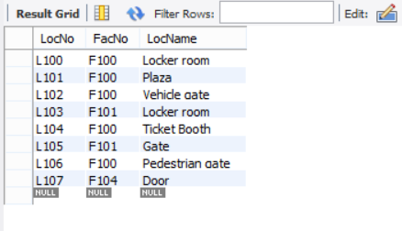

Resulting Table Screenshot:

